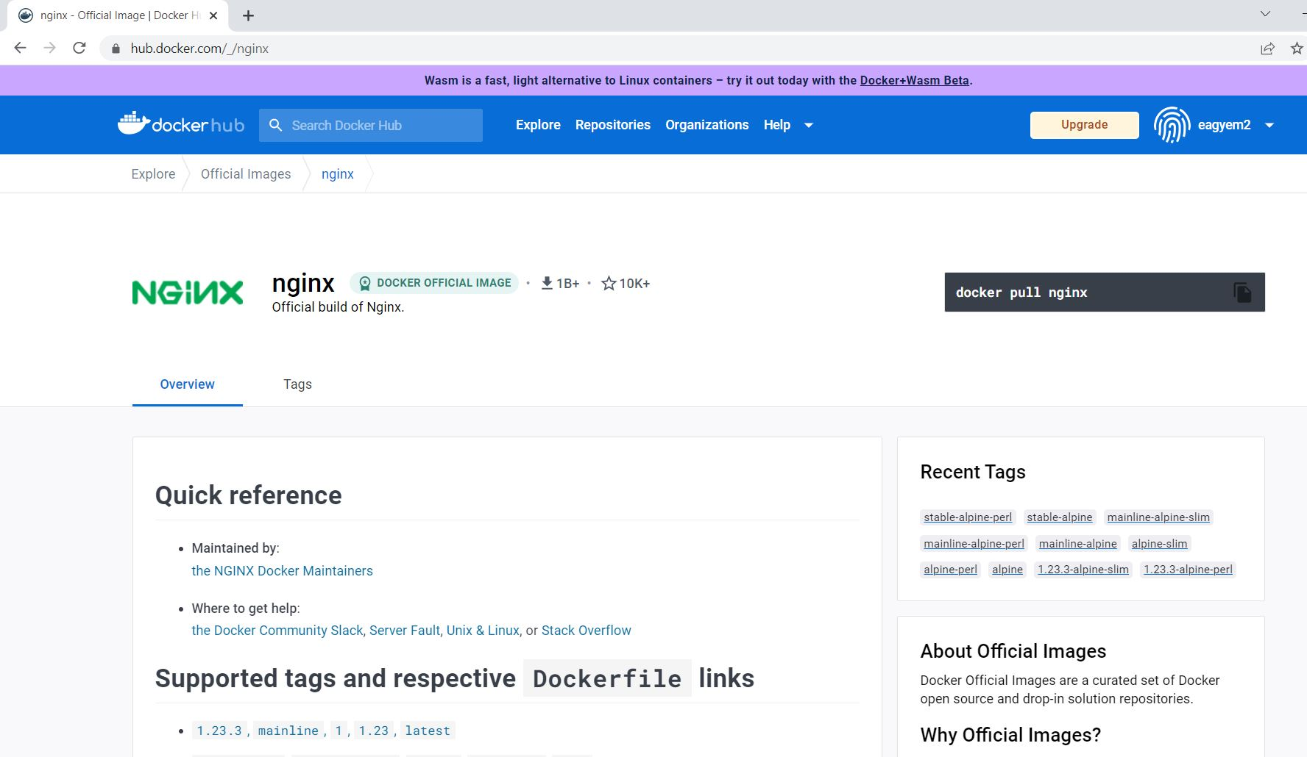

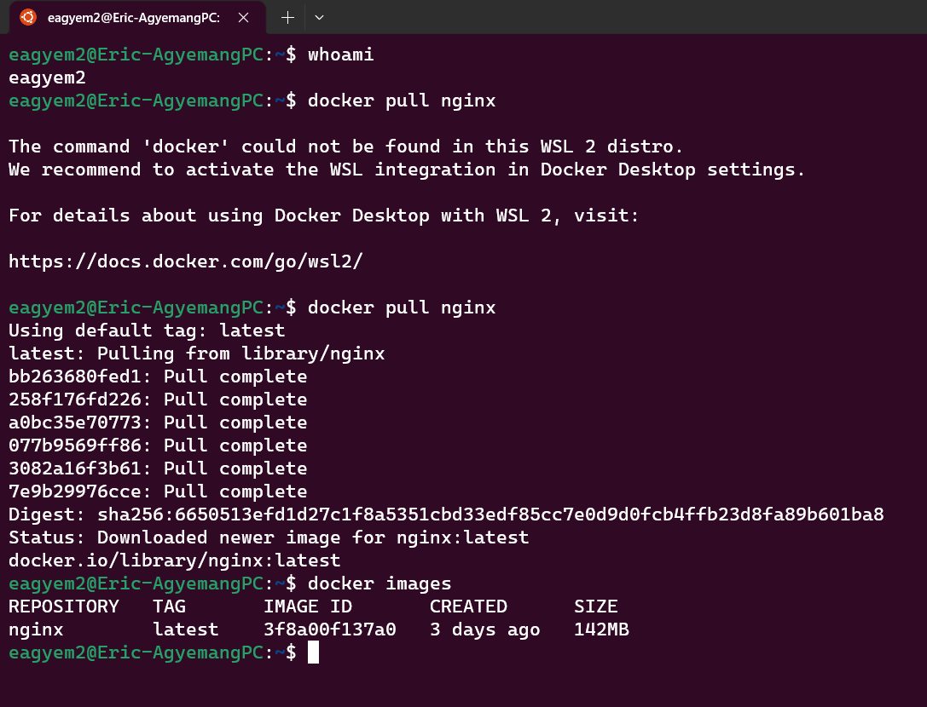

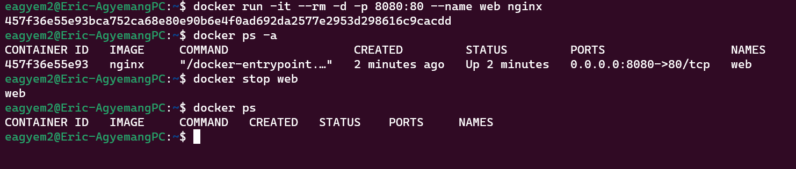

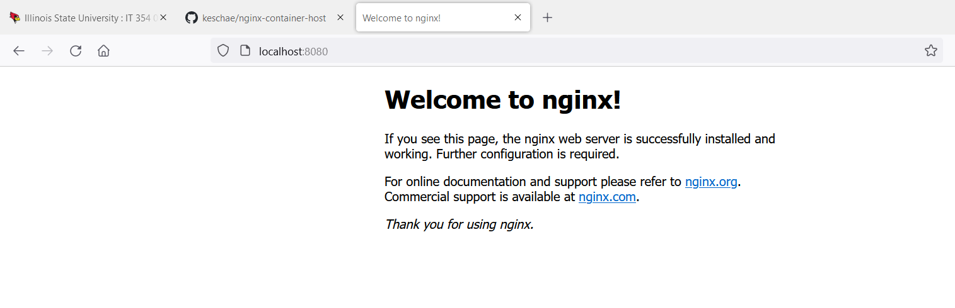



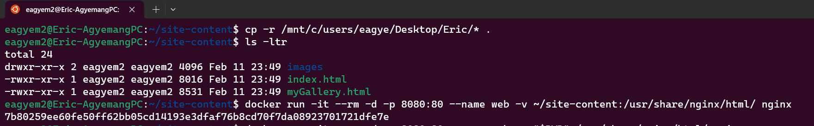

cd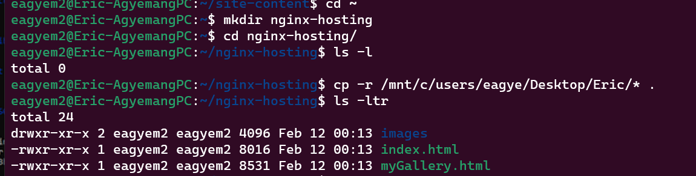

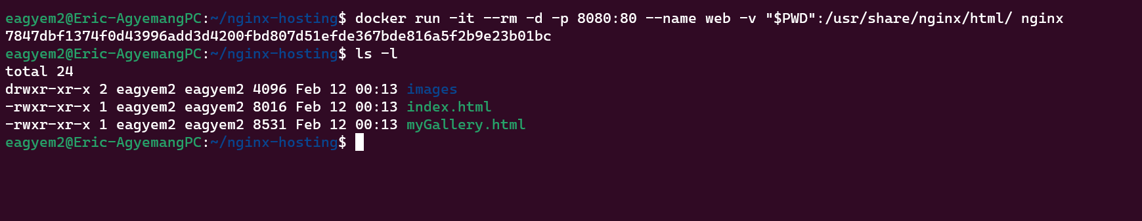

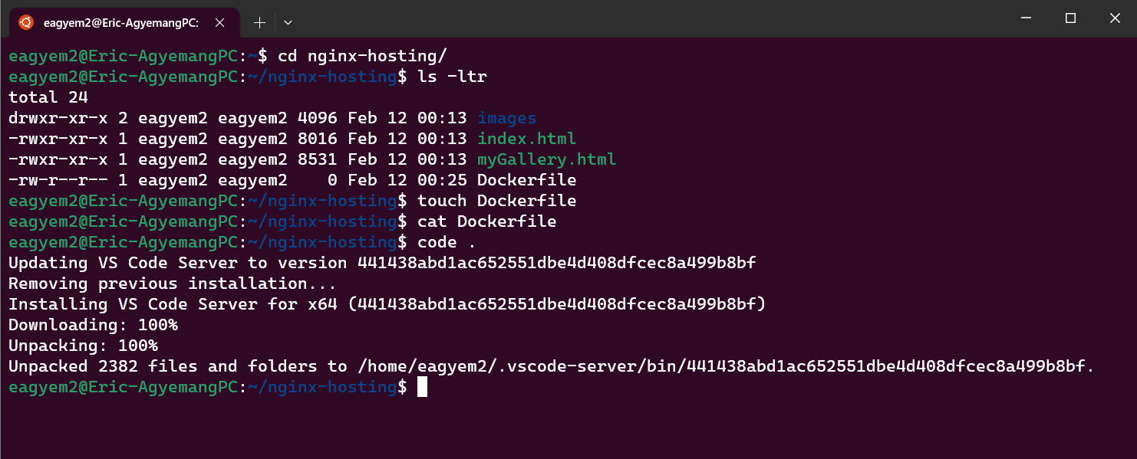

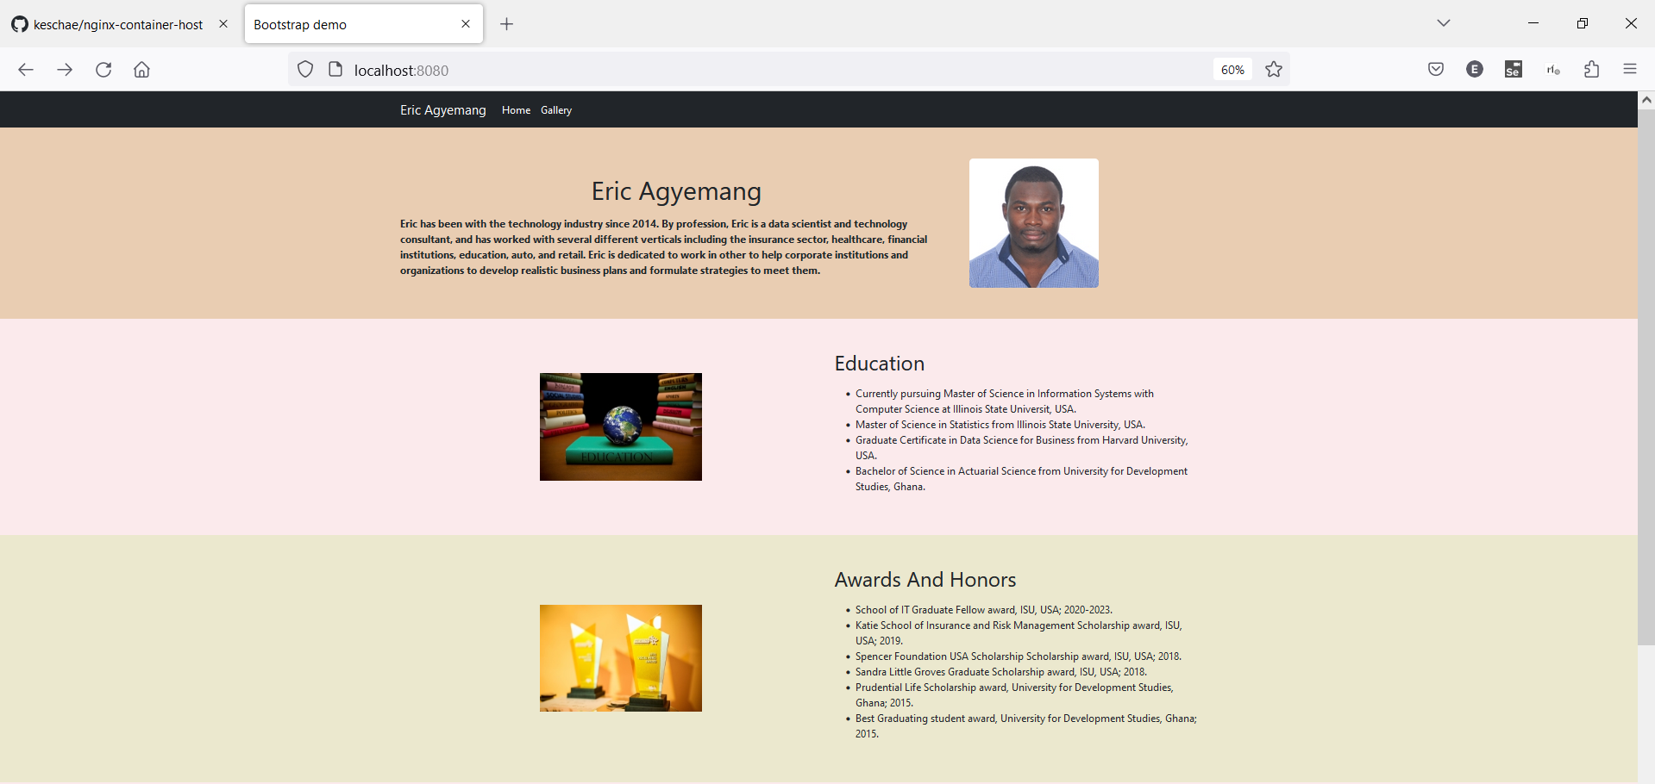

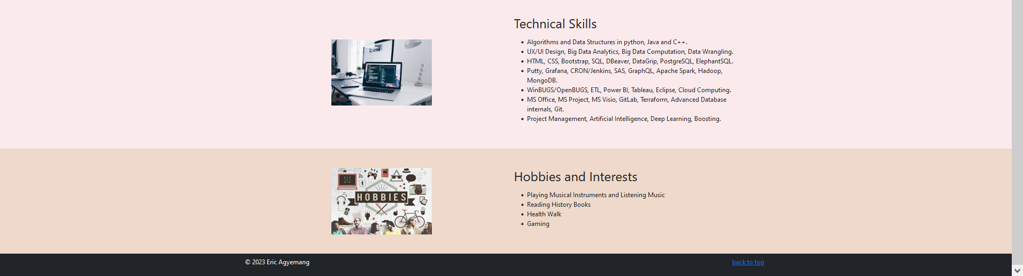

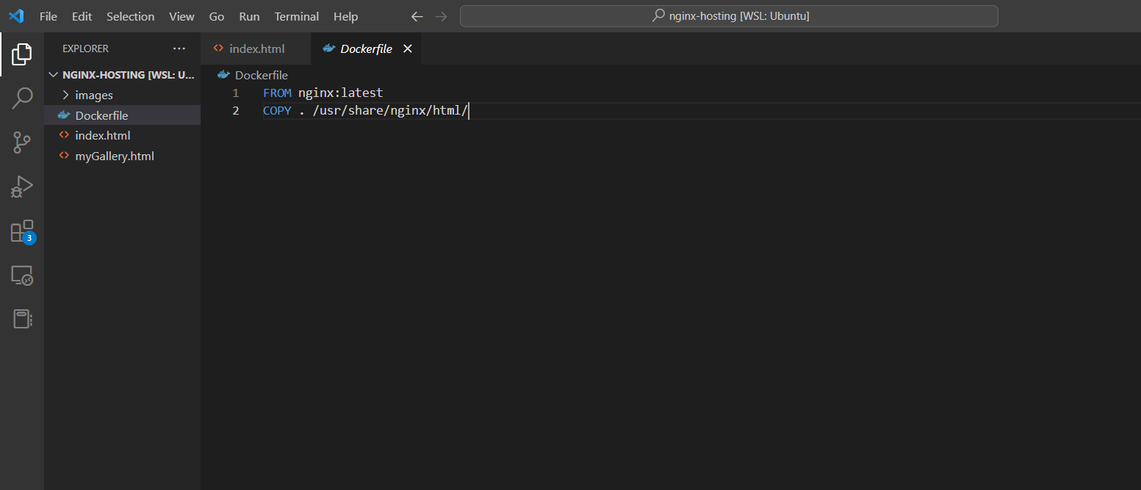

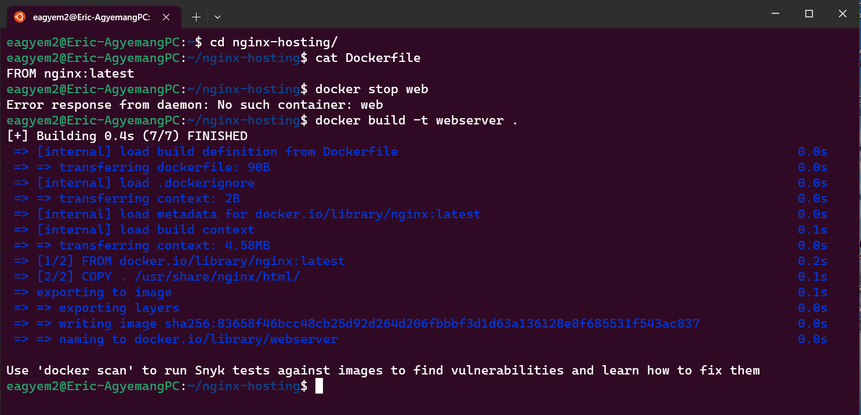





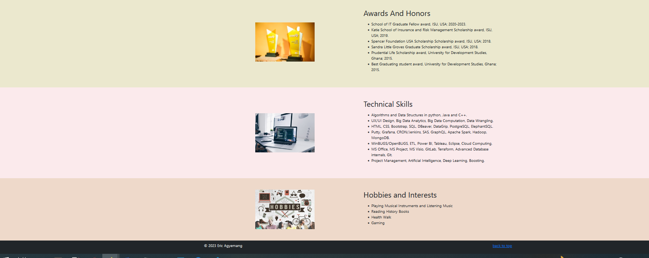

**Additional Question:**

A Dockerfile is a text file that contains a list of commands that the Docker daemon calls while creating an image. To build a custom image, we will need to create a Dockerfile and add our commands to it. In the same directory as that of the image folder, we create a file named Dockerfile and paste the command below in it.

FROM nginx:latest

COPY . /usr/share/nginx/html/

It contains all the information that Docker needs to know to run the app. These include a base Docker image to run from, location of your project code, any dependencies it has, and what commands to run at start-up. It is used as a simple way to automate the image creation process.

The first line of the code will is used to pull the nginx:latest image to our local machine and then build our custom image on top of it. The second line is used to copy all files in the same folder as the Dockerfile into /usr/share/nginx/html/ directory inside the container overwriting the default index.html file provided by nginx:latest

The key note here is that, it is used as a simple way to automate the image creation process.